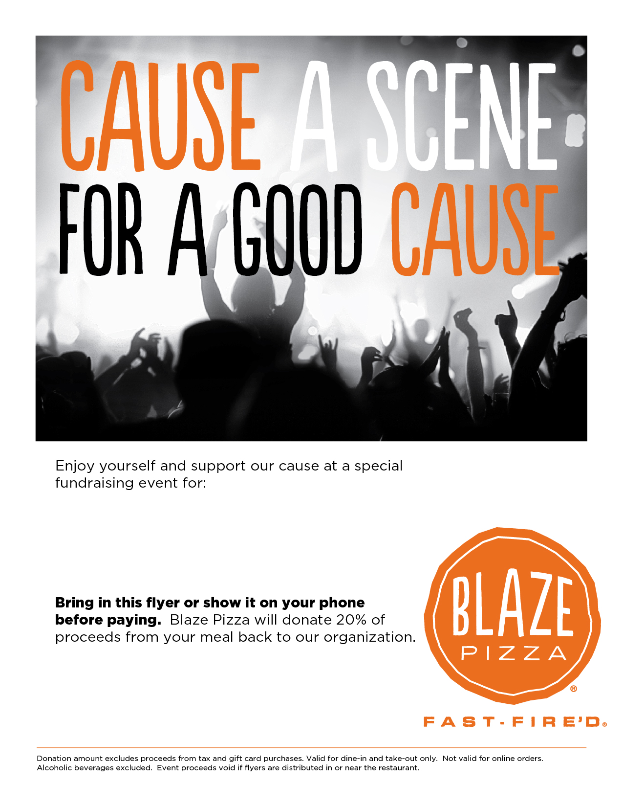live

**Organization Name:** **Clive Learning Academy**

**Date: March 10,2020**

**Time: 4:30 pm – 8:00 pm**

**Location: Blaze Pizza – Valley West Mall**